sponsored by the Centre for Korean Research

The Centre for Korean Research is pleased to present:

Film Screening & Discussion: “The Last Tear,” a documentary about comfort women in Asia and Korea

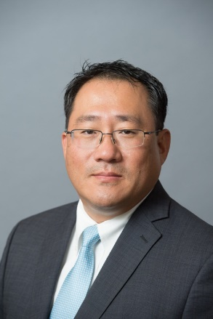

By Dr. Jae H. Ku (Producer) Christopher HK Lee (Director)
John’s Hopkins University

Thursday, January 27th, 2017
3:30-5:00 pm

Room #120, C.K. Choi Building
1855 West Mall, Vancouver , BC V6T 1Z2

Abstract: This documentary feature film tells a story about sexual violence against women, yet most of its victims are silenced. One such sad episode is that of the “comfort women,” or more accurately, the estimated 200,000 women who were recruited to sexually serve the Imperial Japanese Army during World War II. As part of this immense system, many young women from all over Japan's occupied territories in Asia were forced into service where they faced rape, torture, and extreme violence at military camps, euphemistically termed “comfort stations.” The film has been selected and screened at over 100 international film festivals with multiple awards since its release on August 15, 2016.

Bio: Jae H. Ku is the Director of the U.S.-Korea Institute at SAIS. Before joining the U.S.-Korea Institute, he was the Director of the Human Rights in North Korea Project at Freedom House. He has taught at the Johns Hopkins University School of Advanced International Studies, Hankuk University of Foreign Studies (Seoul, Korea), Brown University, Yonsei University (Seoul, Korea), and Sookmyung Women’s University (Seoul, Korea). His research interests are: Inter-Korean Relations, U.S.-Korea relations, Democracy in Asia, and Human Rights in North Korea. He has been a recipient of both Fulbright and Freeman fellowships. Dr. Ku holds a Ph.D. from the Johns Hopkins School of Advanced International Studies, M.Sc. from the London School of Economics, and A.B. from Harvard University.

Bio: Christopher H.K. Lee is an award-winning filmmaker/writer/publisher and media artist. He has over 27 years of multi-cultural and diverse industry experience in the fields of architecture, interactive media, animations, and films as a director/producer and over 12 years of lecturing experience at prestigious colleges in both South Korea and the U.S. Mr. Lee has produced many feature and short films, including several others that raise awareness of Korean history, culture, and current affairs titled “I am Grace,” “Rescued by Fate,” and “Fading Away.”

For more information on “The Last Tear,” please see the attached poster.

