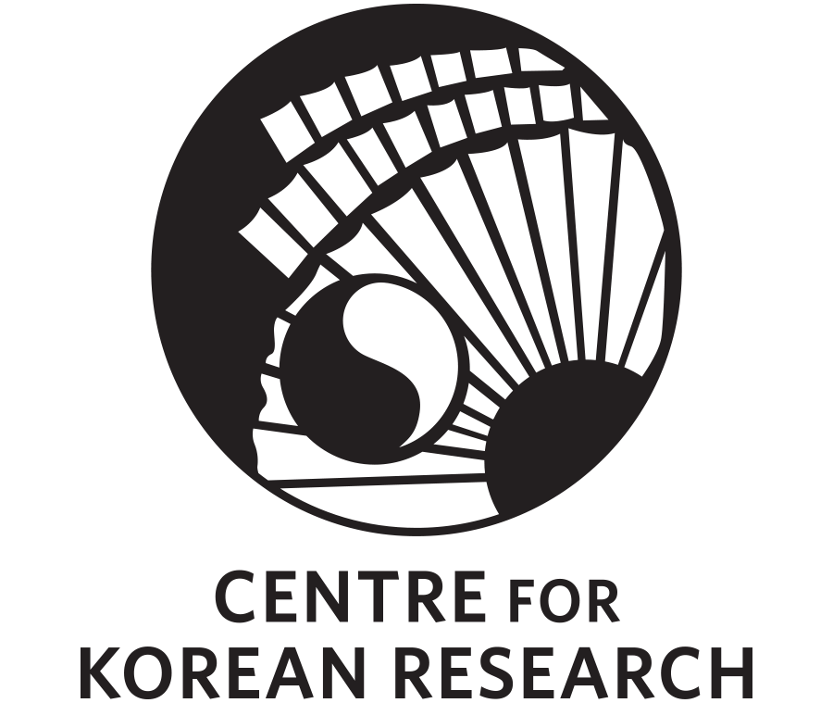
sponsored by the Centre for Korean Research

The Centre for Korean Research (CKR) is pleased to present:

“Where Is Korea Going?: Thoughts From Korea’s Leading Contemporary Philosopher”

By Dr. Young-Oak Kim
Hanshin University, Yanbian University

Friday, March 24, 2017
11:30 a.m. – 1:00 p.m.
(Registration 11:00-11:25 a.m.)
Auditorium, Asian Centre
1871 West Mall, Vancouver, BC V6T 1Z2

*Lunch will be provided
*This seminar will be conducted in both English and Korean
*A public screening of Koguryo (2016, presented in Korean with English subtitles), a documentary film produced by Dr. Kim, will follow the seminar and lunch

RSVP REQUIRED: Please Click Here to RSVP

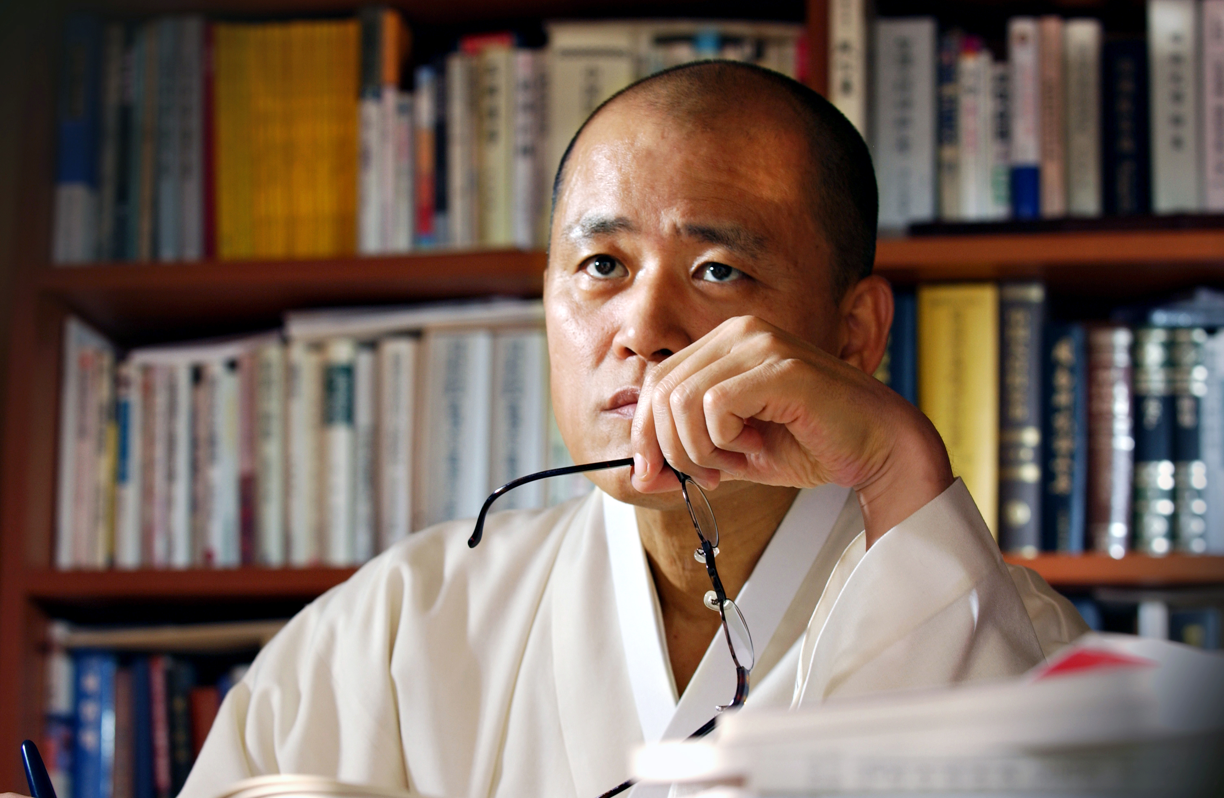

Bio: Dr. Young-Oak Kim金容沃, popularly known as “Master Doh-ol檮杌先生,” is widely considered as the leading contemporary philosopher in South Korea. Dr. Kim has sold over 3 million copies of his 75 monographs, making him the best-selling book author of all time. His works cover a wide array of topics, including philosophy, history, medicine, religion, aesthetics, martial arts, movies, drama, and contemporary politics. A series of his lectures on Confucianism, Taoism, and Buddhism were aired on national networks and garnered unprecedented acclaim. As a translator of Chinese classics into the modern Korean language, his works are considered the most authoritative translations used in Korea. He earned a bachelor’s degree in philosophy from Korea University, where he later served as a tenured professor, and received advanced degrees from the National Taiwan University, the University of Tokyo, and Harvard University. He also graduated from Wonkwang Medical School and practiced the medical profession. His recent work in English, The Great Equal Society: Confucianism, China and the 21st Century was published by World Scientific in 2014, and by Academia Sinica of Social Sciences, Beijing.

Please see the attached poster for more details.

If you have any questions, please contact CKR or Prof. Kyung-Ae Park at 604-822-2267.

