sponsored by the Centre for Korean Research

The Centre for Korean Research is pleased to present:

“Modern Times in North Korea: Scenes from the Founding Years”

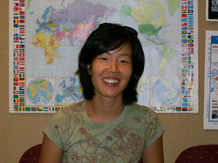

By Suzy Kim,
Rutgers University

Friday, January 23rd
3:30-5:00 pm
Conference room #120, C.K. Choi Building
1855 West Mall

Abstract: North Korea is often portrayed in mainstream media as a backward place, a Stalinist relic without a history worth knowing. But during its founding years (1945-1950), North Korea experienced a radical social revolution when everyday life became the primary site of political struggle, including quite deliberately a feminist agenda. With historical comparisons to revolutions in the early 20th century, Suzy Kim introduces her book through rarely seen archival photos, situating the North Korean revolution within the broader history of modernity.

Bio: Suzy Kim is Assistant Professor in the Department of Asian Languages & Cultures at Rutgers University. She received her Ph.D. in History from the University of Chicago. Her book Everyday Life in the North Korean Revolution, 1945-1950 was published by Cornell University Press in 2013. Her teaching and research interests focus on modern Korean history with particular attention to social and cultural history, gender studies, oral history, and social theory.

