
sponsored by the Centre for Korean Research

The Centre for Korean Research is pleased to present:

“Making Sense of a Worker Self-Immolation in 1970s South Korea”
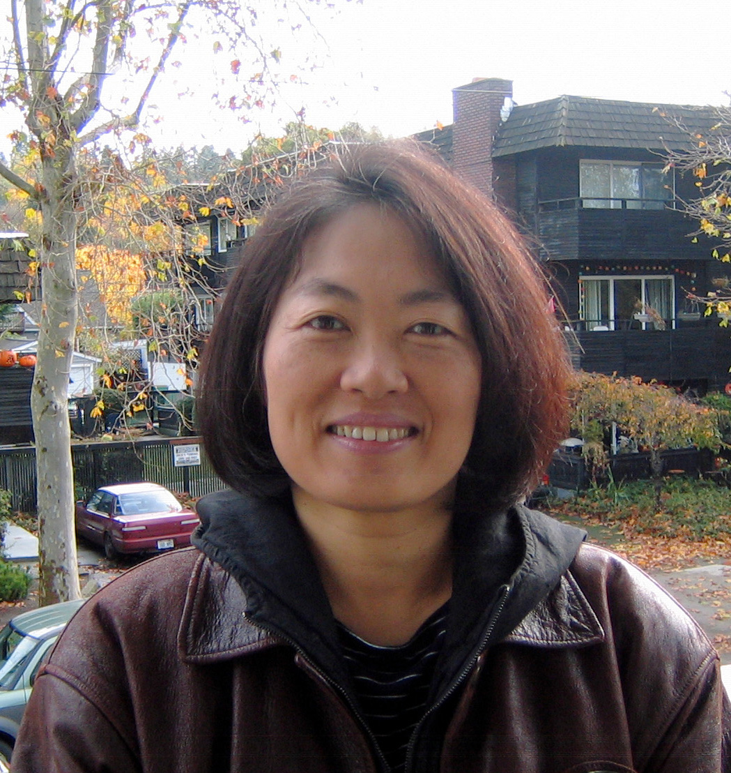

By Hwasook Nam,

University of Washington
Friday, March 13th
3:30-5:00 pm
Conference room #120, C.K. Choi Building
1855 West Mall

Abstract: The death of young garment worker Chun Tae-il by self-immolation on November 13, 1970 has been widely acknowledged among both activists and scholars as the watershed event for the South Korean democracy movement and for the labor movement in particular. As dissident activists searched for a viable counter-narrative against the powerful developmentalist discourse of the Park Chung Hee and Chun Doo Hwan regimes over the 1970s and 1980s, a particular narrative of the meaning of Chun Tae-il’s life and death emerged and became hegemonic in the anti-authoritarian democracy movement. Cho Young-rae’s biography of Chun, written over the 1970s and published in 1983, played a key role in fixing and disseminating Chun’s thought and legacy. This paper examines how Cho read texts by Chun, and provides an alternative reading of Chun Tae-il’s story, which sheds light on the changes the 1970s brought to South Korean politics.

Bio: Hwasook Nam is a James B. Palais Endowed Associate Professor in Korea Studies, holding a joint appointment in the Jackson School of International Studies and the Department of History at the University of Washington. She received her B.A. and M.A. degrees in Korean history from Seoul National University and her Ph.D. from the University of Washington. Her first book, Building Ships, Building a Nation: Korea’s Democratic Unionism under Park Chung Hee (2009, University of Washington Press) won the James B. Palais Book Prize in 2011, and has been translated into Korean (2014, Humanitas). She is currently working on the history of martyrdom in the South Korean labor movement and on gender politics of the post-1945 decades.

